CS 255 System Design Document Template

UML Diagrams

UML Use Case Diagram
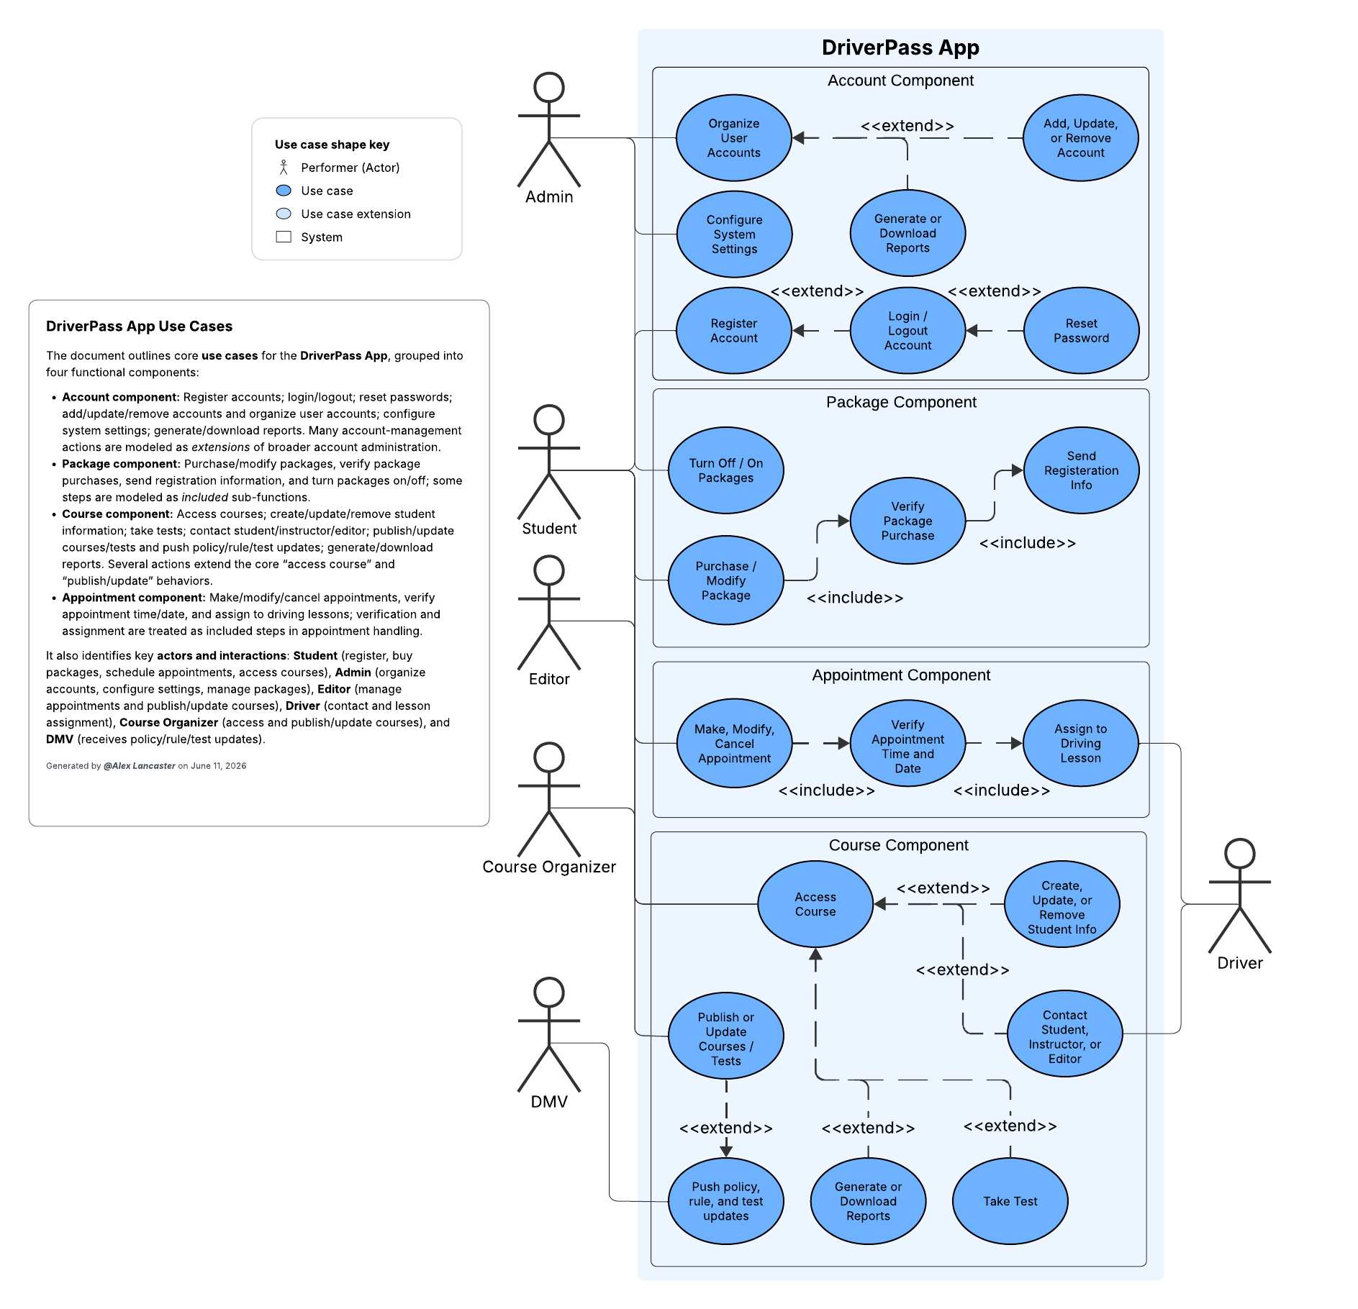

UML Activity Diagrams
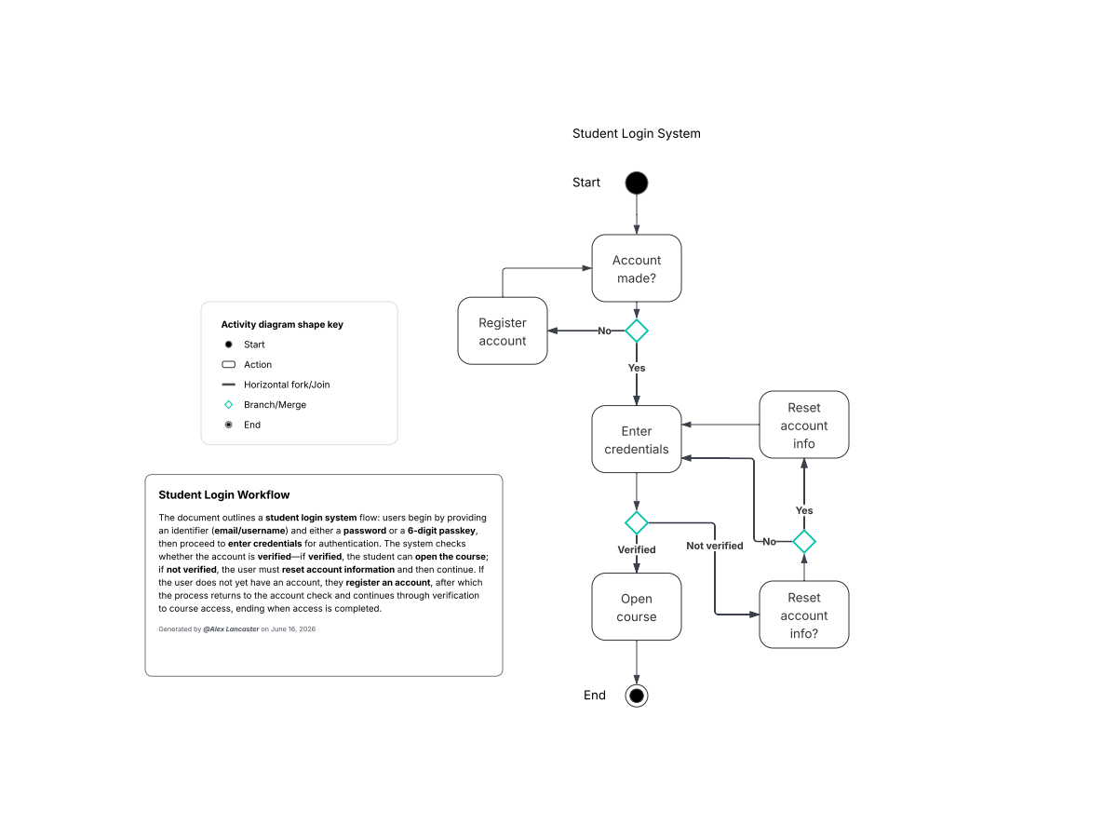

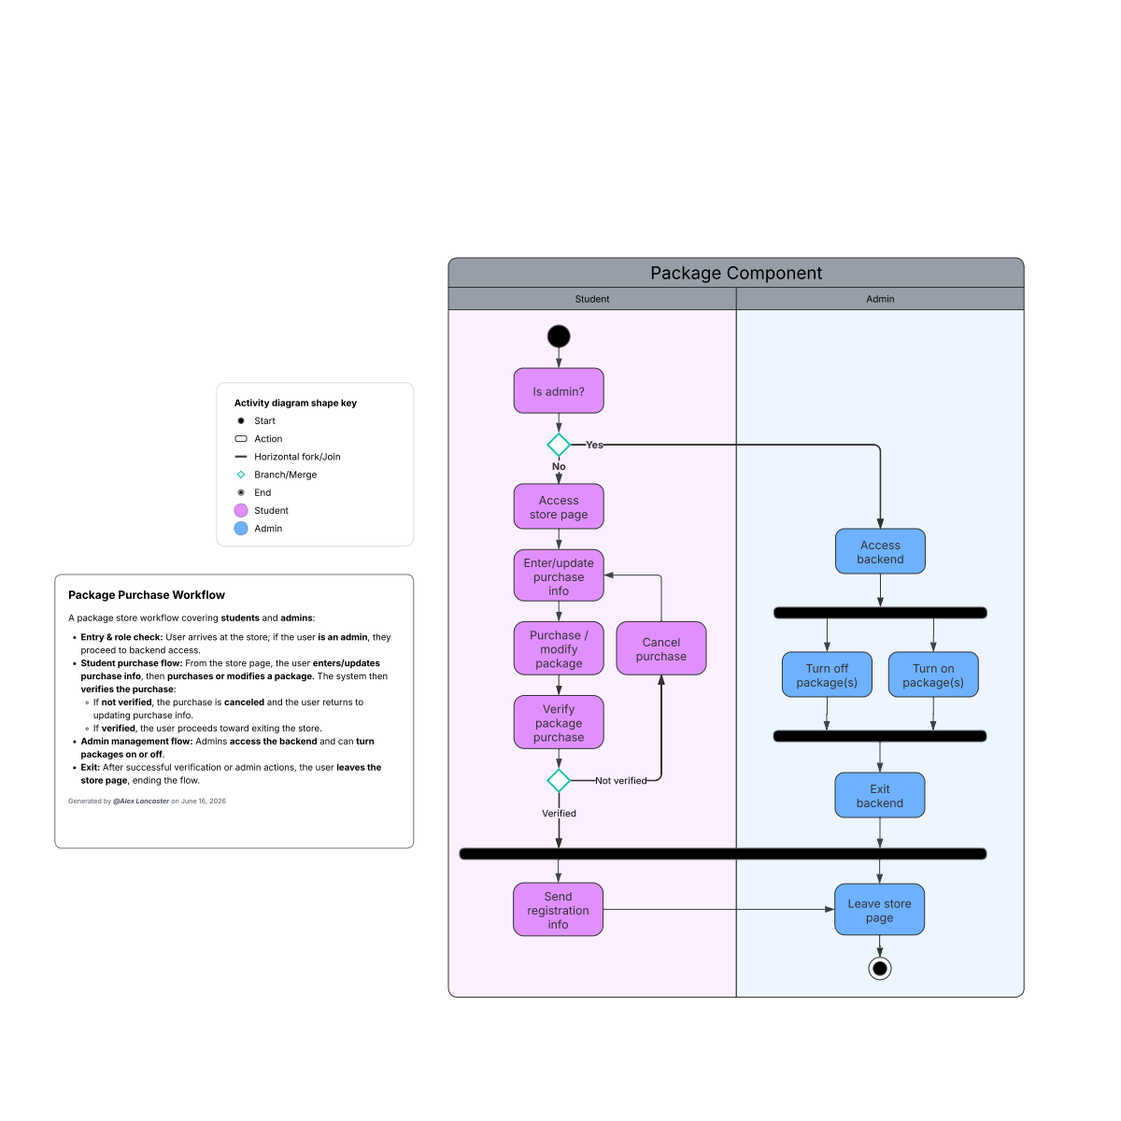

UML Sequence Diagram
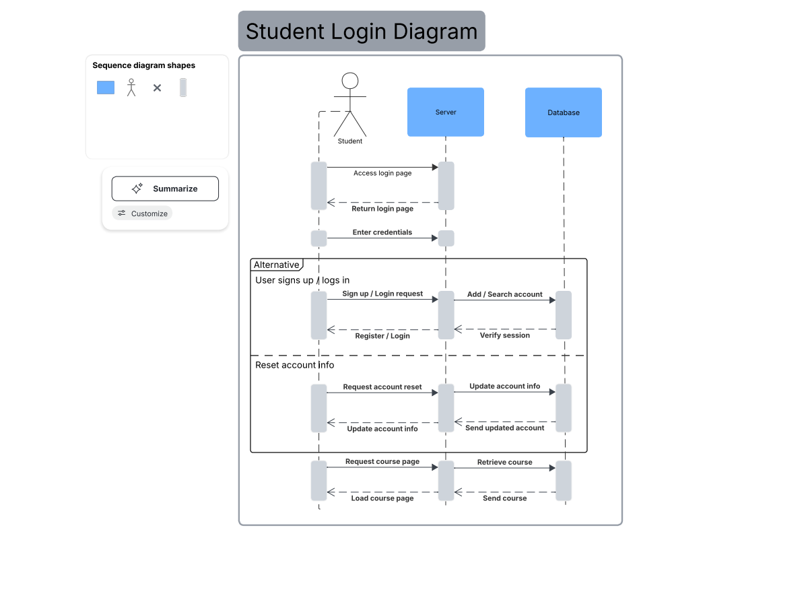

UML Class Diagram

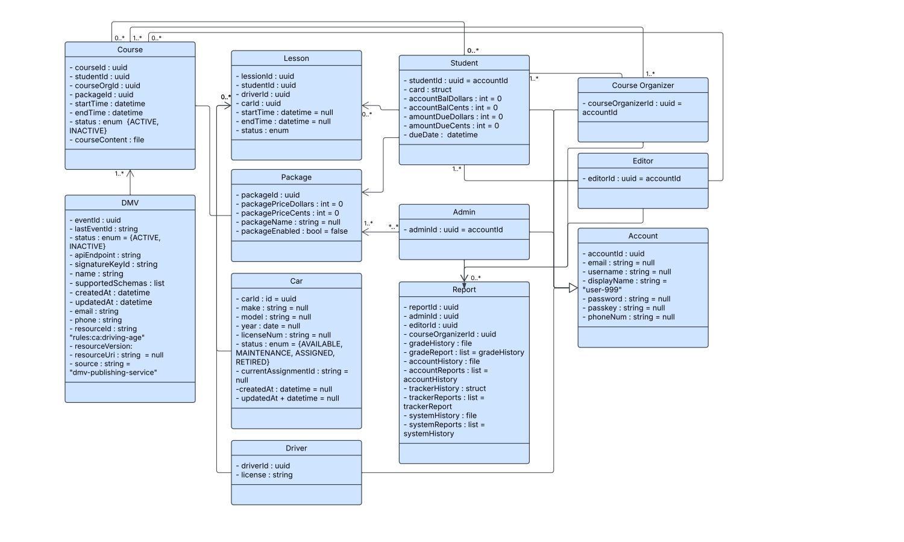

Technical Requirements

Software:
- Web API designed to retrieve up-to-date, inter-regional exam-like questions, accurate exam simulations, and detailed explanations for every answer from the DMV.
- Domain APIs that provide CRUD endpoints for car, driver, student, course organizer, and editor information.
- Reporting API with endpoints to build/download PDF/CSV reports based on activity, grades, and history with role-based access checks and audit logging.
- Analytics API to aggregate metrics endpoints, anonymized for performance, usage, and item statistics. Must be integrated with reporting.
- Admin API to organize users and roles, content moderation, and key rotation endpoints.
- A pseudo-anonymous, secure, and decentralized database administration platform to hold and analyze account information, course information, tracker history, and system history.
- A cross-platform web server that works on browsers across different devices and operating systems.
- The web server is hosted on a decentralized cloud platform to enhance security, reduce costs, and improve scalability by distributing data across multiple nodes, reducing single points of failure.
- A cross-platform web app version of the website that can be downloaded and used across different devices and operating systems.
- Front-end of the web app must use modern frameworks to create a responsive and accessible design, support internationalization/localization, support PWA packaging, validate input, and have secure storage.

Hardware:
- The CPU, GPU, and memory will mainly come from the users’ devices themselves when they access the front-end until they send a request to the web server.
- Server-side, cloud VMs are sized per load, storage nodes are peer nodes distributed across regions for redundancy, and dedicated backup nodes and bastion hosts for admin access are made.
- Load balancers are used for API traffic distribution.

Tools:
- Frameworks like Node.js and Express are needed for web hosting and creating/connecting with APIs.
- CI/CD can be taken care of by GitHub Actions and YAML code.
- Server-side libraries for PDF/CSV generation by Puppeteer.
- Libsodium for encryption.
- HashiCorp Vault for decentralized secrets and KMS.
- ModSecurity for WAF and security
- Spheron for decentralized, community-centric cloud hosting.
- Testing is done with unit/integration frameworks, such as Jest and Mocha.

Infrastructure:
- Decentralized hosting infrastructure that uses a distributed node network.
- Decentralized cloud providers must offer multi-region deployment across at least 2 regions to avoid single-provider failure.
- For networks, use private VPCs and VPNs between admin nodes and decentralized nodes and public API gateways with rate limiting and CDN edge caching.
- For backups and disaster recovery, automate incremental backups, geo-replicated snapshots, RTO/RPO targets that are tested before restoration procedures begin.
- Configurable retention policies to meet regulatory needs and data export and deletion workflows that support pseudo-anonymization.

